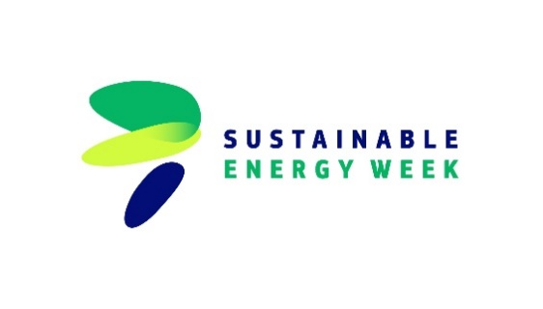
BIOSOLFarm Conference Week Rostock, June 2024
South Baltic Farms – an essential part of renewable energy

Report from study tours and BIOSOLFarm conference in Rostock

From June 18-21, 2024, the BIOSOLFarm project partners convened in the Hanseatic and university city of Rostock for a partner meeting to discuss the project's status and progress. Additionally, the partners undertook several study visits to farms in the surrounding area. The week culminated in a conference day featuring a series of presentations by invited speakers and project partners, focusing on renewable energy topics.
On Tuesday, June 18, project partners arrived in Rostock and gathered for a joint dinner to welcome all participants. The following day, the group met at the University of Rostock for a partner meeting before embarking on a study tour at Hof Postma. This family-run dairy farm, located in Lambrechtshagen near Rostock, has been in operation since 1991 and manages around 600 milking cows, 270 young cattle, and 120 female calves. The participants were introduced to the key aspects and management of the farm, as well as the infrastructure for the farm's own renewable energies. Spanning around 500 hectares of arable and grassland, the Postma farm leases a rooftop solar system on its stables and operates another system for its own consumption, which is fed into the grid. Cattle manure and food leftovers are utilized in a biogas plant with 350 kWp of electricity production and 600 kWp heat production. For more than 10 years, the owners have been awaiting permission to erect wind turbines on their farmland. This was followed by a comprehensive farm tour and a subsequent discussion. The Postma farm, run by Mr. Nils Postma, exemplifies the progressive approach to renewable energies necessary for today's energy transition.
On Thursday, June 20, the study tour continued at BGA Kalsow, where the partners observed a highly professional farming business with two roof solar systems with a total output of around 200 kW, as well as a biogas plant with a 250 kW electrical and thermal output, supported by a local heating network of approximately 2000 meters with 17 transfer stations and a large thermal buffer storage tank. Additionally, BGA Kalsow operates three wind turbines, each generating 2.3 MW. With this strong focus on renewable energies, several villages in the surrounding area are supplied with electricity and heat from this farm.
The tour also included a visit to Söhnholz – Schweinezucht KG, a farm specializing in piglet production, fattening, and arable farming with a total utilized agricultural area of around 550 hectares, of which the majority of the area is leased. There is currently a roof-mounted solar system with an output of 48 kWp on the roof of the barn. However, the system is operated by the landlord. As pig production is very energy-intensive, particularly due to piglet rearing, the installation of a solar system is being considered in order to reduce the use of woodchippings on the farm.
On Friday, June 21, the BIOSOLFarm Conference took place as a Sustainable Energy Day at the University of Rostock. This inaugural project conference focused on biomass, highlighting the potential of biogas production. The conference aimed to provide a platform for discussing biomass utilization methods and heat utilization prospects, presented by Dr. Lenz from the German Biomass Research Centre. Dr. Narra from the University of Rostock presented the advantages and challenges of hybridizing energy systems, explaining that hybrid systems combining different energy sources offer advantages such as securing the energy supply for both electricity and heat. Other topics covered included the status of renewable energies in agriculture in Mecklenburg-Vorpommern, heat transition with biogas, the provision and use of renewable heat in agriculture, and current developments in biogas production in Poland, Germany, and Lithuania.
In summary, the first BIOSOLFarm conference was a resounding success, featuring intensive exchanges between project partners and key stakeholders, and packed with valuable insights and information on renewable energies.

